PC Propagation:
Before Propagation
- No one is doing PCAT
- LTP is stopped

- Lock USER
- ALTER USER SOTELCO_REPORT ACCOUNT LOCK;
- ALTER USER SOTELCO_FRAUD ACCOUNT LOCK;

- Versioning -→ service version -→ select service version
Choose the last active date
- Versioning-→ Reseller version → select reseller version
Choose vimplecom and the last active date.
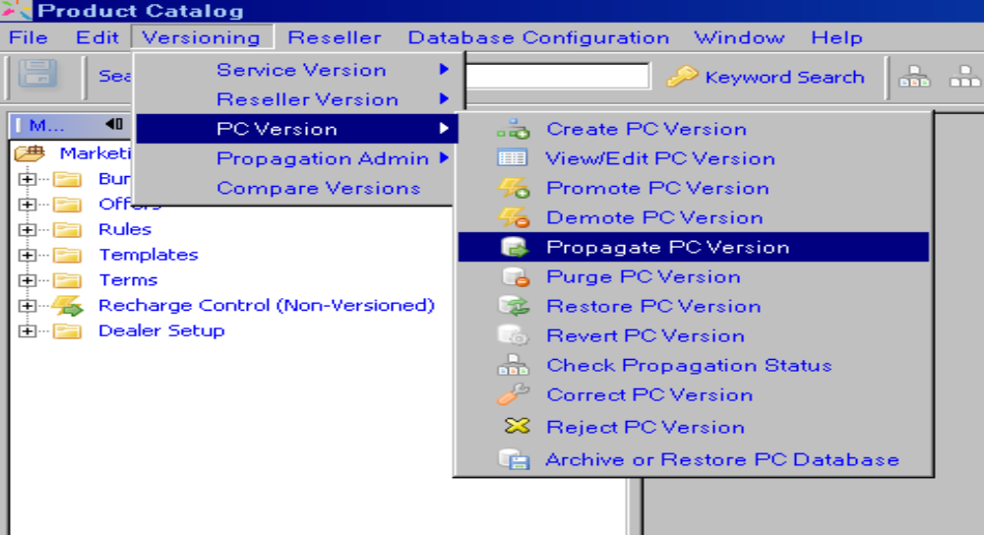

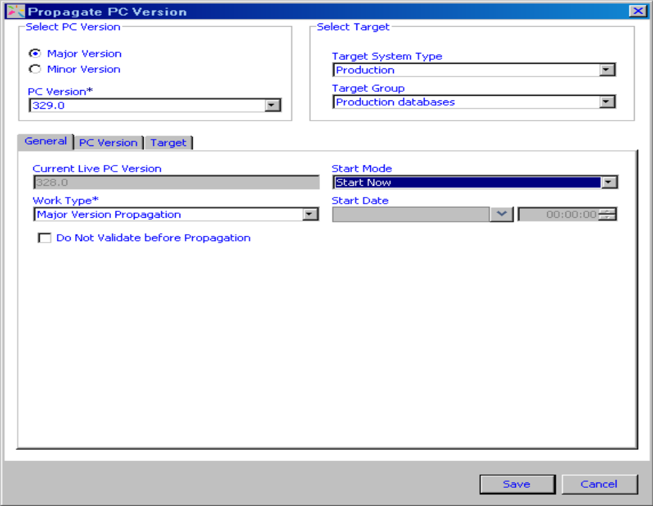

After clicking Save the propagation is started.
--How to monitor propagation process --

- During Propagation
- Checking the Sessions in PCAT DB from PL/SQL

- How to check process we stand on UPM:
- /home/jboss/cbs_workflow/propagation/LOG:
- ps –ef | grep –I propa

- Checking the process status in PCAT application
- Versioning→ PC Version-→ Check propagation status
- After Propagtion
- Check the process status in PCAT application
Versioning→ PC Version-→ Check propagation status
- LTP needs to be started

- Unlock USER
- ALTER USER SOTELCO_REPORT ACCOUNT UNLOCK;
- ALTER USER SOTELCO_FRAUD ACCOUNT UNLOCK;

select max(reseller_version_id) from reseller_version where reseller_id = 6

